# Homework: AMD and RequireJS Homework

This document defines the homework assignments from the ["OOP" Course @ Software University](https://softuni.bg/trainings/coursesinstances/details/8). Please submit as homework a single zip / rar / 7z archive holding the solutions (source code) of all below described problems.

## Module Separation

**Separate** the modules from the last homework problem (**Problem 1. TODO List Module**) into different files. The file **dependencies** should be as follows:

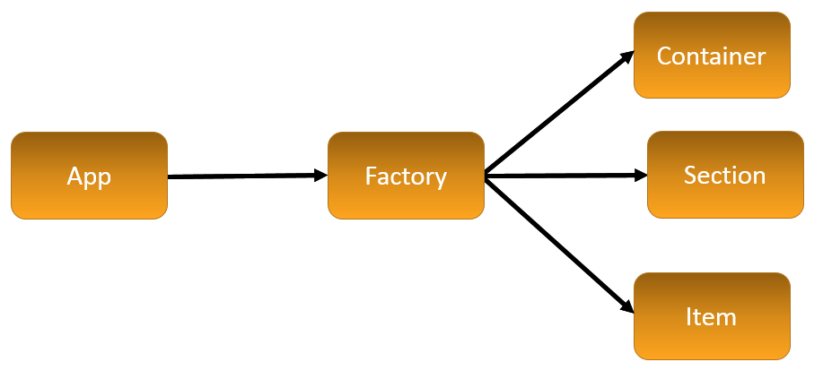

**Factory** should return objects of **Container**, **Section** and **Item** classes. **App** should operate with the objects returned by Factory. You are allowed to include **only one script tag** in HTML. Use **RequiredJS** to achieve this.